Database Soal Managemen Basis Data AIK21343

**DAFTAR ISI**

DAFTAR ISI...........................................................................................................................................1 UJIAN TENGAH SEMESTER 2007/2008 ................................................................................................ 3 UJIAN TENGAH SEMESTER 2008/2009 ................................................................................................ 4 UJIAN TENGAH SEMESTER 2009/2010 ................................................................................................ 5 UJIAN AKHIR SEMESTER 2007/2008 .................................................................................................... 6 UJIAN AKHIR SEMESTER 2009/2010 R1 ................................................................................................ 7 UJIAN AKHIR SEMESTER 2009/2010 R2 ................................................................................................ 8 UJIAN TENGAH SEMESTER 2009/2010 ................................................................................................ 9 UJIAN TENGAH SEMESTER 2010/2011 ...............................................................................................10 UJIAN AKHIR SEMESTER 2010/2011 ................................................................................................... 11 UJIAN MID SEMESTER 2010/2011 ..................................................................................................... 12 UJIAN MID SEMESTER 2011/2012 ..................................................................................................... 13 UJIAN MID SEMESTER 2012/2013 ..................................................................................................... 15 UJIAN AKHIR SEMESTER 2012/2013 ................................................................................................... 16 UJIAN TENGAH SEMESTER 2013/2014 ...............................................................................................17 UJIAN AKHIR SEMESTER 2013/2014 ................................................................................................... 18 UJIAN TENGAH SEMESTER 2014/2015 ...............................................................................................20 UJIAN AKHIR SEMESTER 2014/2015 ................................................................................................... 21 UJIAN TENGAH SEMESTER 2015/2016 ...............................................................................................23 UJIAN AKHIR SEMESTER 2015/2016 ................................................................................................... 24 UJIAN TENGAH SEMESTER 2017/2018 ............................................................................................... 27 UJIAN AKHIR SEMESTER 2017/2018 ................................................................................................... 29 UJIAN TENGAH SEMESTER 2018/2019 ............................................................................................... 30 UJIAN AKHIR SEMESTER 2018/2019 ................................................................................................... 32

DIKLAT HMIF Page 2

Database Soal Managemen Basis Data AIK21343

**UJIAN TENGAH SEMESTER 2007/2008**

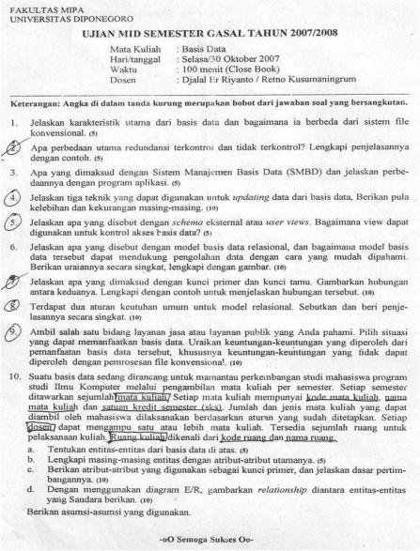DIKLAT HMIF Page 3

Database Soal Managemen Basis Data AIK21343

**UJIAN TENGAH SEMESTER 2008/2009**

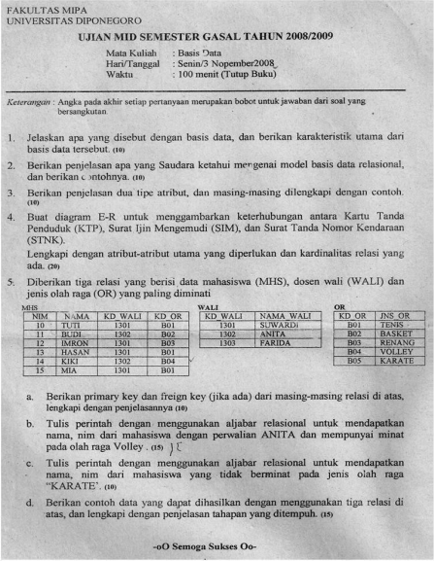DIKLAT HMIF Page 4

Database Soal Managemen Basis Data AIK21343

**UJIAN TENGAH SEMESTER 2009/2010**

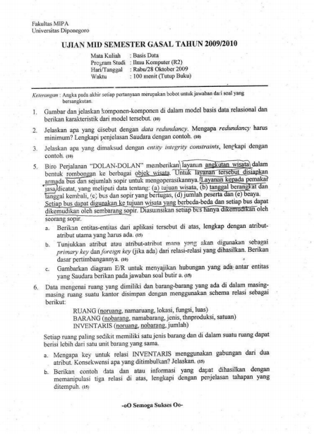DIKLAT HMIF Page 5

Database Soal Managemen Basis Data AIK21343

**UJIAN AKHIR SEMESTER 2007/2008**

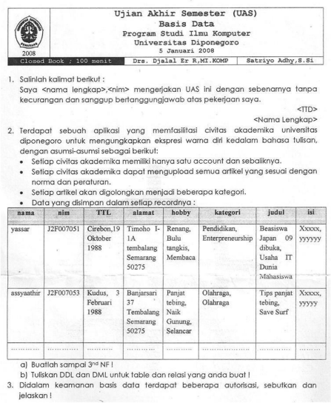DIKLAT HMIF Page 6

Database Soal Managemen Basis Data AIK21343

**UJIAN AKHIR SEMESTER 2009/2010 R1**

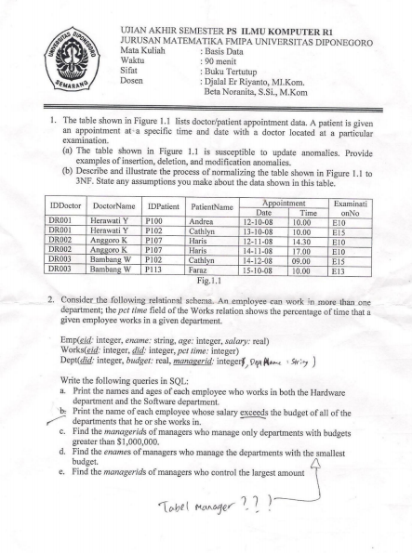DIKLAT HMIF Page 7

Database Soal Managemen Basis Data AIK21343

**UJIAN AKHIR SEMESTER 2009/2010 R2**

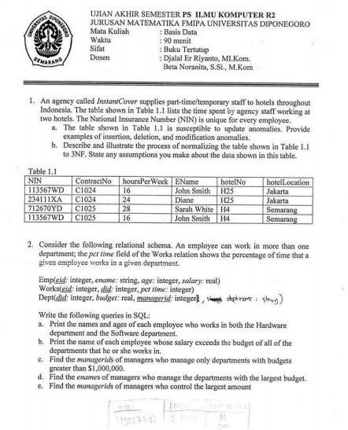DIKLAT HMIF Page 8

Database Soal Managemen Basis Data AIK21343

**UJIAN TENGAH SEMESTER 2009/2010**

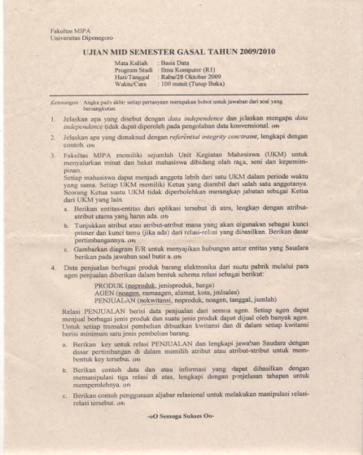DIKLAT HMIF Page 9

Database Soal Managemen Basis Data AIK21343

**UJIAN TENGAH SEMESTER 2010/2011**

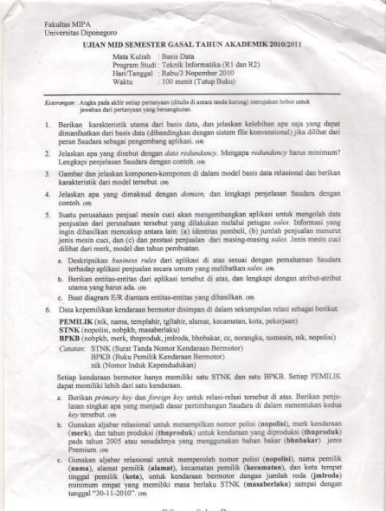DIKLAT HMIF Page 10

Database Soal Managemen Basis Data AIK21343

**UJIAN AKHIR SEMESTER 2010/2011**

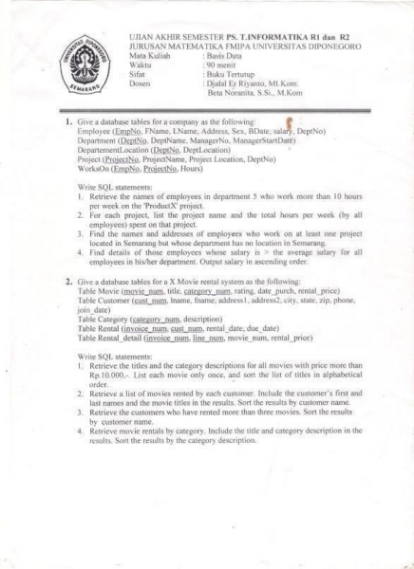DIKLAT HMIF Page 11

Database Soal Managemen Basis Data AIK21343 **UJIAN MID SEMESTER 2010/2011**

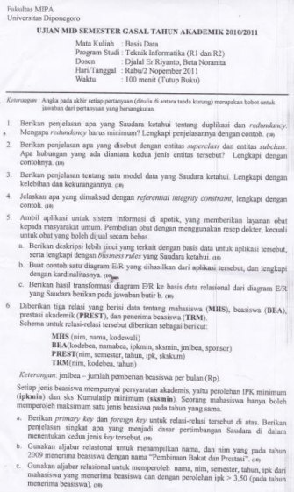

DIKLAT HMIF Page 12

Database Soal Managemen Basis Data AIK21343 **UJIAN MID SEMESTER 2011/2012**

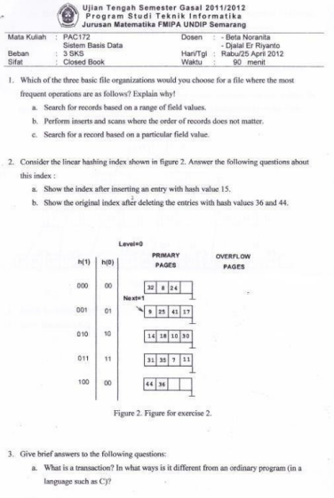DIKLAT HMIF Page 13

Database Soal Managemen Basis Data AIK21343 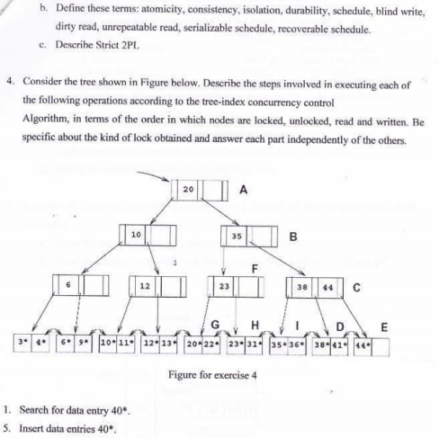

DIKLAT HMIF Page 14

Database Soal Managemen Basis Data AIK21343

**UJIAN MID SEMESTER 2012/2013**

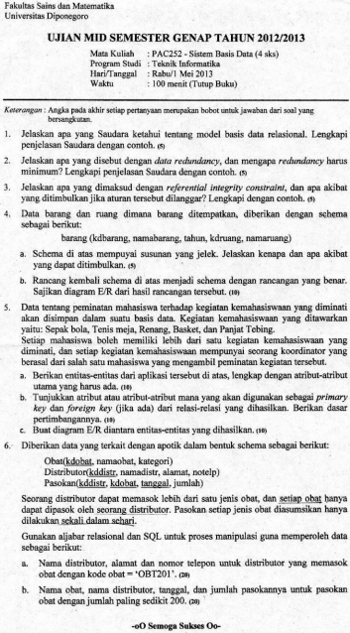DIKLAT HMIF Page 15

Database Soal Managemen Basis Data AIK21343

**UJIAN AKHIR SEMESTER 2012/2013**

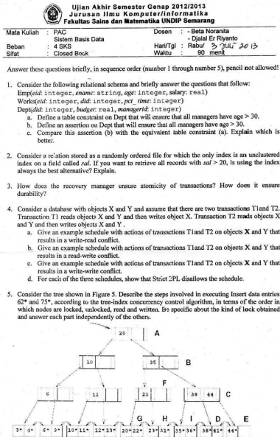DIKLAT HMIF Page 16

Database Soal Managemen Basis Data AIK21343

**UJIAN TENGAH SEMESTER 2013/2014**

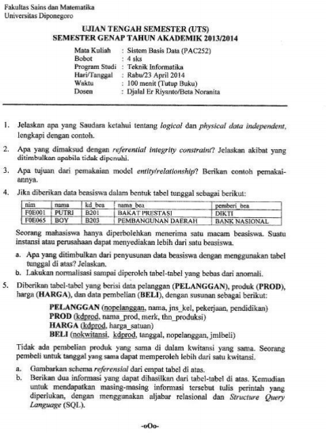DIKLAT HMIF Page 17

Database Soal Managemen Basis Data AIK21343

**UJIAN AKHIR SEMESTER 2013/2014**

****DIKLAT HMIF Page 18

Database Soal Managemen Basis Data AIK21343 

DIKLAT HMIF Page 19

Database Soal Managemen Basis Data AIK21343

**UJIAN TENGAH SEMESTER 2014/2015**

****DIKLAT HMIF Page 20

Database Soal Managemen Basis Data AIK21343

**UJIAN AKHIR SEMESTER 2014/2015**

****DIKLAT HMIF Page 21

Database Soal Managemen Basis Data AIK21343 DIKLAT HMIF Page 22

Database Soal Managemen Basis Data AIK21343

**UJIAN TENGAH SEMESTER 2015/2016**

****DIKLAT HMIF Page 23

Database Soal Managemen Basis Data AIK21343

**UJIAN AKHIR SEMESTER 2015/2016**

****DIKLAT HMIF Page 24

Database Soal Managemen Basis Data AIK21343 DIKLAT HMIF Page 25

Database Soal Managemen Basis Data AIK21343 

DIKLAT HMIF Page 26

Database Soal Managemen Basis Data AIK21343 **UJIAN TENGAH SEMESTER 2017/2018**

****DIKLAT HMIF Page 27

Database Soal Managemen Basis Data AIK21343 DIKLAT HMIF Page 28

Database Soal Managemen Basis Data AIK21343 **UJIAN AKHIR SEMESTER 2017/2018**

****DIKLAT HMIF Page 29

Database Soal Managemen Basis Data AIK21343

**UJIAN TENGAH SEMESTER 2018/2019**

****DIKLAT HMIF Page 30

Database Soal Managemen Basis Data AIK21343 **UJIAN TENGAH SEMESTER 2018/2019**

****DIKLAT HMIF Page 31

Database Soal Managemen Basis Data AIK21343 **UJIAN AKHIR SEMESTER 2018/2019**

****DIKLAT HMIF Page 32

Database Soal Managemen Basis Data AIK21343

**UJIAN AKHIR SEMESTER 2018/2019**

****DIKLAT HMIF Page 33